EDA Analysis:

Clean data view:

/* EDA analysis */

select * from MioView1

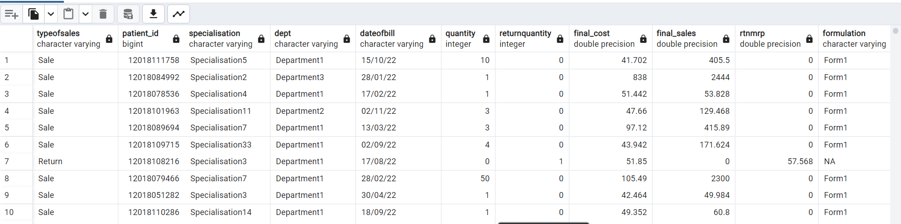

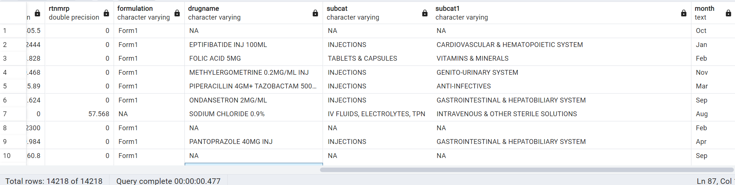

Finding Maximum and Minimum, average and count of quantity of sale and Maximum and minimum, average and count of returnquantity of return items out of sale

-- Descriptive statistics:

-- Maximum quantity, minimum quantity, maximum return quantity, minimum return quantity, avg of quantity and return quantity and total quantity sales and return quantity

select Max(quantity) as "max quantity",

MIN(quantity) as "min quantity",

AVG(quantity) as "avg quantity",

count(quantity) as "no of countity",

MAX(returnquantity) as "max returnquantity",

MIN(returnquantity) as "min returnquantity",

AVG(returnquantity) as "avg returnquantity",

count(returnquantity) as " total returns"

from MioView1

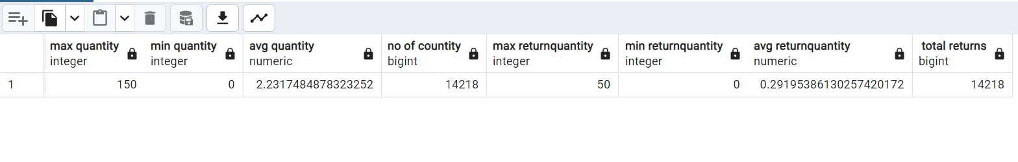

Frequency distribution of type of sales items

--frequency of sales

SELECT typeofsales, COUNT(*) as frequency

FROM MioView1

GROUP BY typeofsales

ORDER BY frequency DESC;

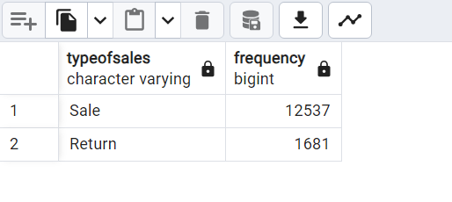

Out of 14218 sales data 12537 are total sales and 1681 is total returns

First Moment Bussiness Decision:

First Moment Business Decision contains mean, median and mode values

Mean:

select round(avg(quantity)) as "average quantity",

round(avg(returnquantity)) as "average returnquantity",

round(avg(final_cost)) as "average final_cost",

round(avg(final_sales)) as "average final_sales",

round(avg(rtnmrp)) as "average of rtnmrp"

from MioView1

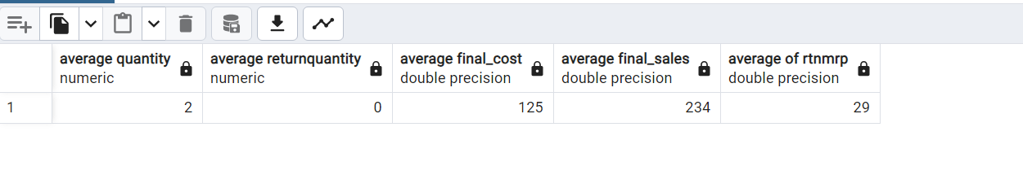

Median:

SELECT QUANTITY_MEDIAN AS QUANTITY_MEDIAN_VALUE,

RETURNQUANTITY_MEDIAN AS RETURNQUANTITY_MEDIAN_VALUE,

FINAL_COST_MEDIAN AS FINAL_COST_MEDIAN_VALUE,

FINAL_SALES_MEDIAN AS FINAL_SALES_MEDIAN_VALUE,

RTNMRP_MEDIAN AS RTNMRP_MEDIAN_VALUE

FROM

(

SELECT

PERCENTILE_CONT(0.5) WITHIN GROUP (ORDER BY quantity) AS median

FROM

MioView1) AS QUANTITY_MEDIAN,

(SELECT

PERCENTILE_CONT(0.5) WITHIN GROUP (ORDER BY RETURNQUANTITY) AS MEDIAN

FROM

MioView1) AS RETURNQUANTITY_MEDIAN,

(SELECT

PERCENTILE_CONT(0.5) WITHIN GROUP (ORDER BY final_cost) AS MEDIAN

FROM

MioView1) AS FINAL_COST_MEDIAN,

(SELECT

PERCENTILE_CONT(0.5) WITHIN GROUP (ORDER BY final_sales) AS MEDIAN

FROM

MioView1) AS FINAL_SALES_MEDIAN,

(SELECT

PERCENTILE_CONT(0.5) WITHIN GROUP (ORDER BY rtnmrp) AS MEDIAN

FROM

MioView1) AS RTNMRP_MEDIAN

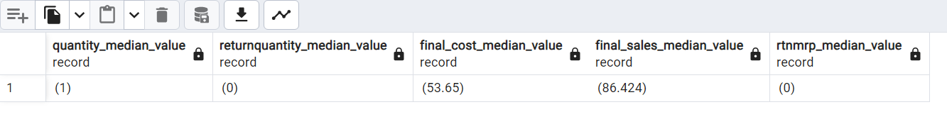

Mode:

select quantity_mode as quantity_mode_value,

return_mode as returnquantity_mode_value,

finalcost_mode as final_cost_mode_value,

finalsales_mode as final_sales_mode_value,

rtnmrp_mode as rtnmrp_mode_valuw

from

(SELECT quantity AS mode_value, COUNT(*) AS frequency

FROM MioView1

GROUP BY quantity

ORDER BY COUNT(*) DESC

LIMIT 1) as quantity_mode,

(SELECT returnquantity AS mode_value, COUNT(*) AS frequency

FROM MioView1

GROUP BY returnquantity

ORDER BY COUNT(*) DESC

LIMIT 1) as return_mode,

(SELECT final_cost AS mode_value, COUNT(*) AS frequency

FROM MioView1

GROUP BY final_cost

ORDER BY COUNT(*) DESC

LIMIT 1) as finalcost_mode,

(SELECT final_sales AS mode_value, COUNT(*) AS frequency

FROM MioView1

GROUP BY final_sales

ORDER BY COUNT(*) DESC

LIMIT 1) as finalsales_mode,

(SELECT rtnmrp AS mode_value, COUNT(*) AS frequency

FROM MioView1

GROUP BY rtnmrp

ORDER BY COUNT(*) DESC

LIMIT 1) as rtnmrp_mode

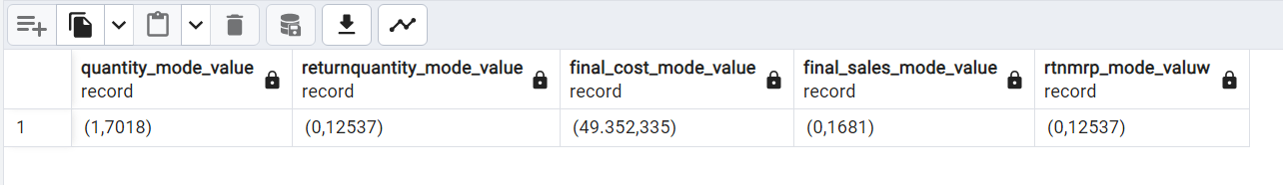

Second Moment Business Decision contains: Variance, standard deviation and range

Variance:

select variance(quantity::numeric) as variance_quantity,

variance(returnquantity::numeric) as variance_returnquantity,

variance(final_cost) as variance_final_cost,

variance(final_sales) as variance_final_sales,

variance(rtnmrp) as variance_rtnmrp

from MioView1

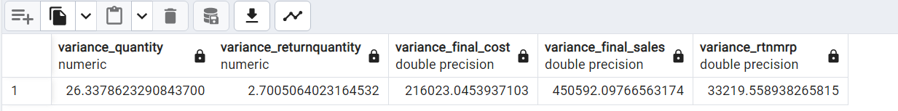

Standard Deviation:

-- standard Deviation:

select stddev(quantity::numeric) as stdev_quantity,

stddev(returnquantity::numeric) as stdev_returnquantity,

stddev(final_cost) as stdev_final_cost,

stddev(final_sales) as stdev_final_sales,

stddev(rtnmrp) as stdev_rtnmrp

from MioView1

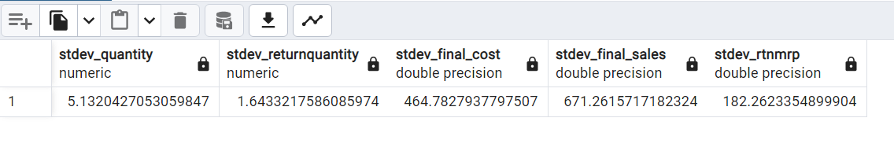

Range:

select

max(quantity) - min(quantity) as range_of_quantity,

max(returnquantity) - min(returnquantity) as range_of_returnquantity,

max(final_cost) - min(final_cost) as range_of_final_cost,

max(final_sales) - min(final_sales) as range_of_final_sales,

max(rtnmrp) - min(rtnmrp) as range_of_rtnmrp

from MioView1;

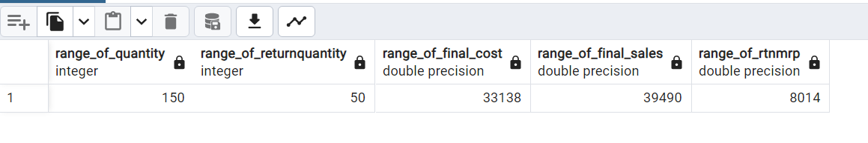

Third Movement Business Decision:

Skewness:

Skewness is a measure of the asymmetry of a distribution

-- Calculate skewness for a numerical column

WITH moments1 AS (

SELECT

AVG(quantity) AS mean_quantity,

STDDEV(quantity) AS stddev_quantity,

AVG(returnquantity) as mean_returnquantity,

STDDEV(returnquantity) as stddev_returnquantity,

AVG(final_cost) as mean_final_cost,

STDDEV(final_cost) as stddev_final_cost,

AVG(final_sales) as mean_final_sales,

STDDEV(final_cost) as stddev_final_sales,

AVG(rtnmrp) as mean_rtnmrp,

STDDEV(rtnmrp) as stddev_rtnmrp

FROM MioView1

)

SELECT

--quantity as quantity,

SUM(POWER(quantity - mean_quantity, 3)) / (COUNT(*) * POWER(stddev_quantity, 3)) AS skewness_for_quantity,

SUM(POWER(returnquantity - mean_returnquantity, 3)) / (COUNT(*) * POWER(stddev_returnquantity, 3)) AS skewness_for_returnquantity,

SUM(POWER(final_cost - mean_final_cost, 3)) / (COUNT(*) * POWER(stddev_final_cost, 3)) AS skewness_for_final_cost,

SUM(POWER(final_sales - mean_final_sales, 3)) / (COUNT(*) * POWER(stddev_final_sales, 3)) AS skewness_for_final_sales,

SUM(POWER(rtnmrp - mean_rtnmrp, 3)) / (COUNT(*) * POWER(stddev_rtnmrp, 3)) AS skewness_for_rtnmrp

FROM

MioView1, moments1

GROUP BY stddev_quantity,stddev_returnquantity,stddev_final_cost,stddev_final_sales,stddev_rtnmrp;

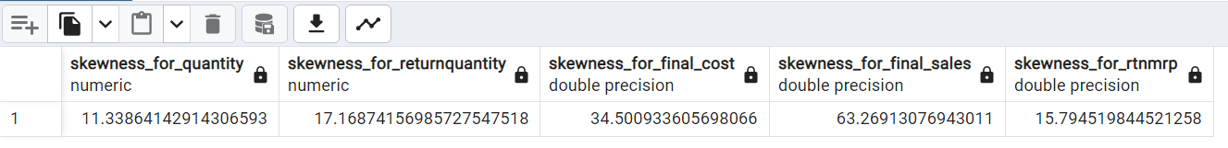

Kurtosis: Kurtosis is a statistical measure that describes the distribution of a dataset.

-- Kurtoris

WITH moments AS (

SELECT

AVG((quantity - (select avg(quantity)from MioView1))::NUMERIC ^ 4) AS fourth_moment1,

AVG((quantity - (select avg(quantity)from MioView1))::NUMERIC ^ 2) AS second_moment1,

AVG((returnquantity - (select avg(returnquantity)from MioView1))::NUMERIC ^ 4) AS fourth_moment2,

AVG((returnquantity - (select avg(returnquantity)from MioView1))::NUMERIC ^ 2) AS second_moment2,

AVG((final_cost - (select avg(final_cost)from MioView1))::NUMERIC ^ 4) AS fourth_moment3,

AVG((final_cost - (select avg(final_cost)from MioView1))::NUMERIC ^ 2) AS second_moment3,

AVG((final_sales - (select avg(final_sales)from MioView1))::NUMERIC ^ 4) AS fourth_moment4,

AVG((final_sales - (select avg(final_sales)from MioView1))::NUMERIC ^ 2) AS second_moment4,

AVG((rtnmrp - (select avg(rtnmrp)from MioView1))::NUMERIC ^ 4) AS fourth_moment5,

AVG((rtnmrp - (select avg(rtnmrp)from MioView1))::NUMERIC ^ 2) AS second_moment5

FROM

MioView1

)

SELECT

fourth_moment1 / (second_moment1 ^ 2) AS kurtosis_for_quantity,

fourth_moment2 / (second_moment2 ^ 2) AS kurtosis_for_returnquantity,

fourth_moment3 / (second_moment3 ^ 2) AS kurtosis_for_final_cost,

fourth_moment4 / (second_moment4 ^ 2) AS kurtosis_for_final_sales,

fourth_moment5 / (second_moment5 ^ 2) AS kurtosis_for_rtmrp

FROM

moments;



Bounce Rate Analysis:

Q1) Total Distinct patients

select count(Distinct patient_id) from MioView1

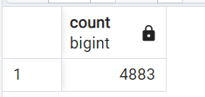

Q2) patient_id count where type of sale is return

select count(Distinct patient_id), typeofsales from MioView1 where typeofsales = 'Return' group by typeofsales

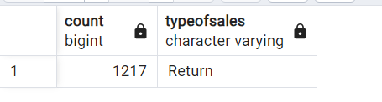

Q3) patient_id count where type of sale is sale

select count(Distinct patient_id), typeofsales from MioView where typeofsales = 'Sale' group by typeofsales

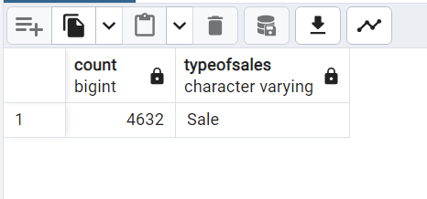

Q4) Overall Bounce Rate

SELECT

COUNT(DISTINCT patient_id) AS total_patients,

COUNT(DISTINCT CASE WHEN returnquantity > 0 THEN patient_id END) AS returning_patients,

(COUNT(DISTINCT CASE WHEN returnquantity > 0 THEN patient_id END) * 100.0) / COUNT(DISTINCT patient_id) AS bounce_rate

FROM MioView1;

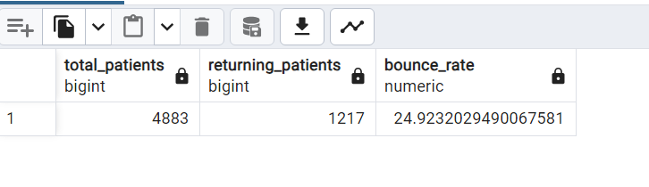

Q4) Bounce rate by specilization

select

specialisation,

count(distinct patient_id) as total_patients,

count(Distinct case when returnquantity > 0 then patient_id end) as returing_patients,

(count(Distinct case when returnquantity > 0 then patient_id end)*100)/count(distinct patient_id) as Bounce_rate

from MioView1

group by specialisation

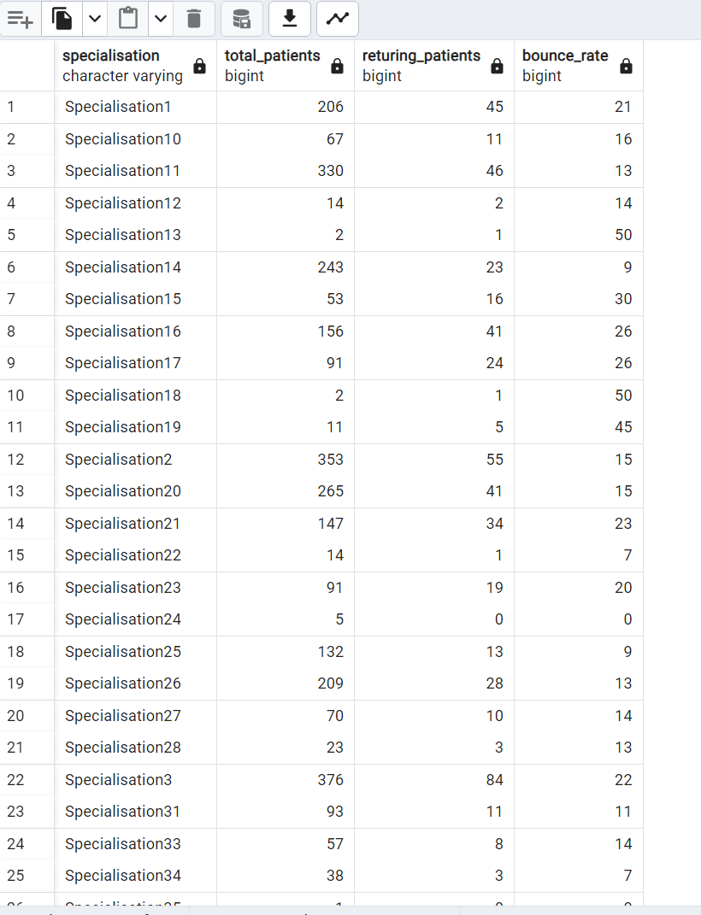

Q5) total cost of purchase that return from subcat

select subcat,round(sum(final_cost)) as total_cost

from MioView where typeofsales = 'Return'

group by subcat

order by total_cost Desc

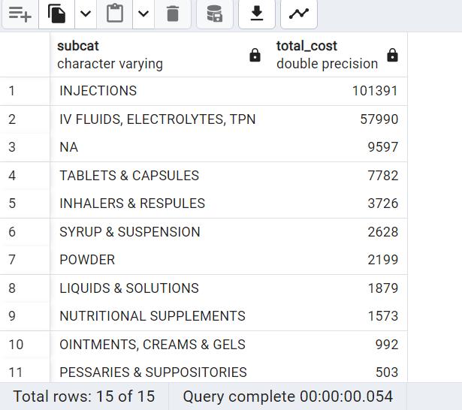

Insight: We can see Injections which hast highest final cost with 101391 followed by iv fluids, electronics, TPN with 57990. Returning this subcategories items will lead to cost burden to the medical inventory

Q6) count of drug returned without sales

select subcat,

count(distinct drugname) as no_of_returned_drugs

from MioView1

where typeofsales = 'Return' and final_sales = 0

group by subcat

order by no_of_returned_drugs desc

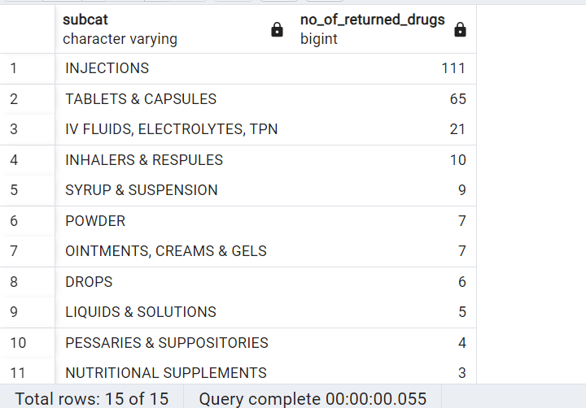

Insight: We can observe from above that subcategory Injection has the highest count of returns with 111 following by Tablets and capsules with 65, which can indicate that the customer disatification with this categories or other factors leading to return

Q7) Return items based on month

select month,count(*) as return_count

from MioView1

where typeofsales = 'Return'

group by month

order by return_count Desc

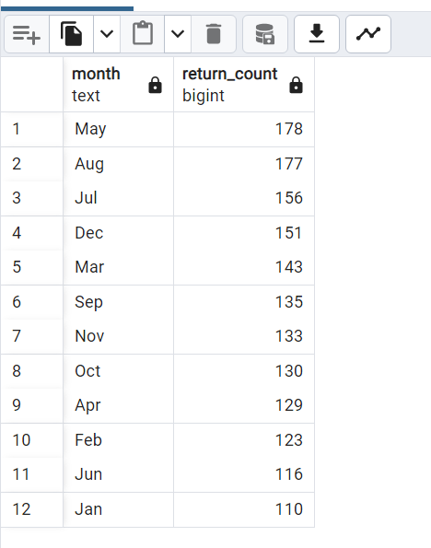

Q8) total sales when sales is return

select typeofsales,

sum(final_sales) as total_final_sales

from MioView1

group by typeofsales;

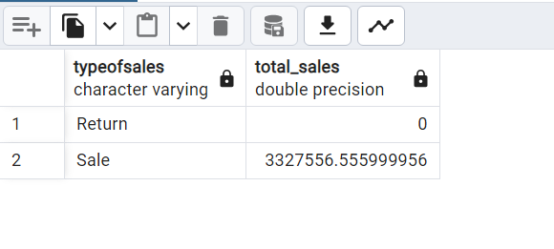

Even though return was done it is not effecting the total sales

Q9) durgs which are mostly return

select drugname, count(*) as return_count

from MioView1

where returnquantity > 0

group by drugname

order by return_count Desc

limit 10;

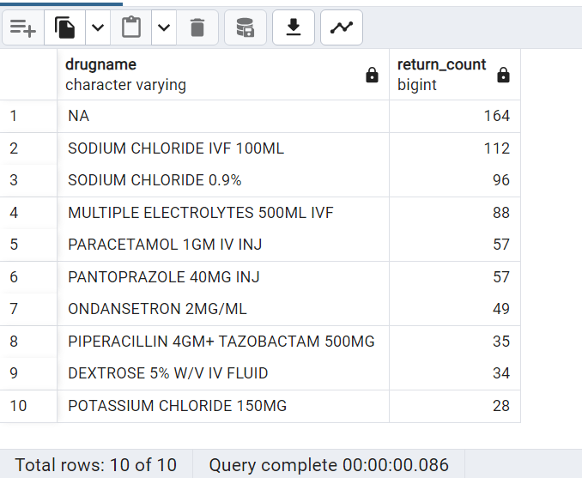

Q10) Total sales based on month

select month,round(avg(final_sales)) as avg_sales from MioView1 group by month order by avg_sales Desc

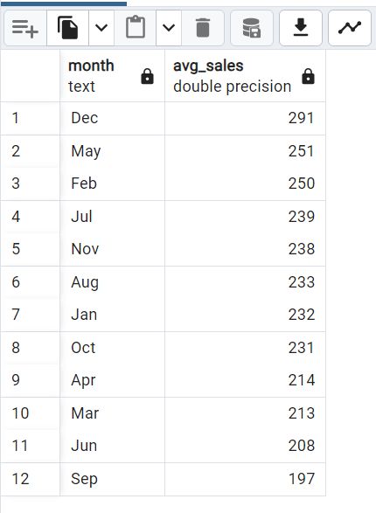

Q11) Average quantity of durg purchases

select drugname,round(Avg(quantity)) as AVG_quantity from MioView1 group by drugname

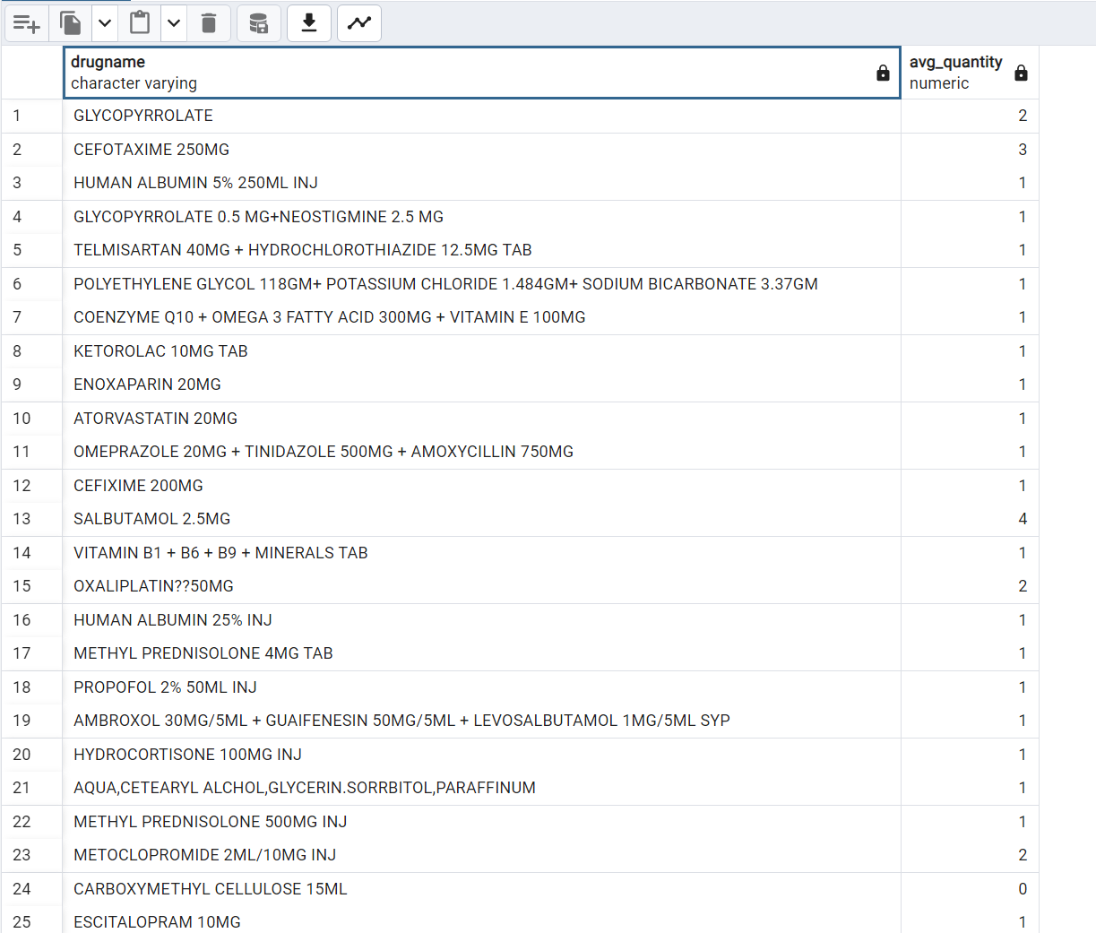

Q12) Relation between quantity and total sales

SELECT

CORR(quantity, final_sales) AS correlation

FROM MioView1;

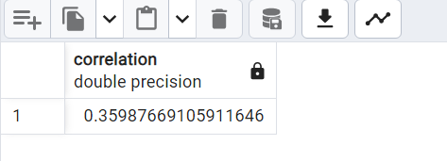

Q13) Average Sales based on Sepcialisation

SELECT

specialisation,

ROUND(AVG(final_sales)) AS avg_sales

FROM MioView

GROUP BY specialisation

ORDER BY avg_sales DESC;

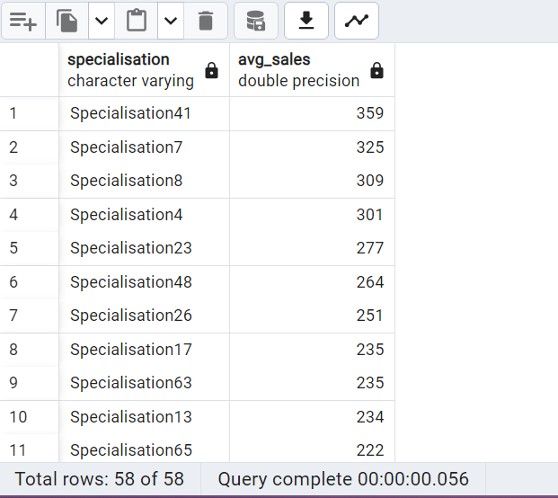

Q14) Frequency of return quantity

select returnquantity,count(*) as frequency

from MioView1

where returnquantity > 0

group by returnquantity

order by returnquantity

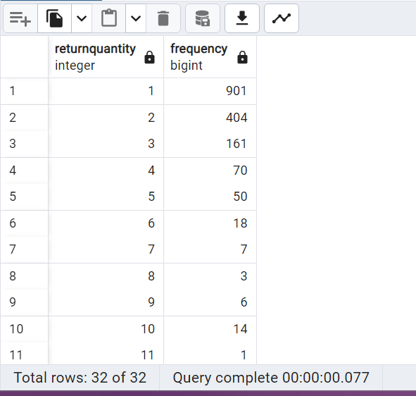

901 times 1 item is returned after purchase followed by 401 times for 2 items. 50 items also returned at 3 times

Conclusion and insights:

From the above analysis we can see the sub categories Injections and tablets were returned frequently , so there may be some dissatisfaction with this products we need to check for those reasons for the items returned, the data we analyse does not consists that field so there is no correct finding for the reasons

We can these two categories injections, tablets, IV fluids return frequently and it costs lots of money, finding the reason for these returns we can reduce the amount of money lose to inventory

We can find highest average sales in December month and the highest returns in may month. Finding the reason we can increase the sales in other months.